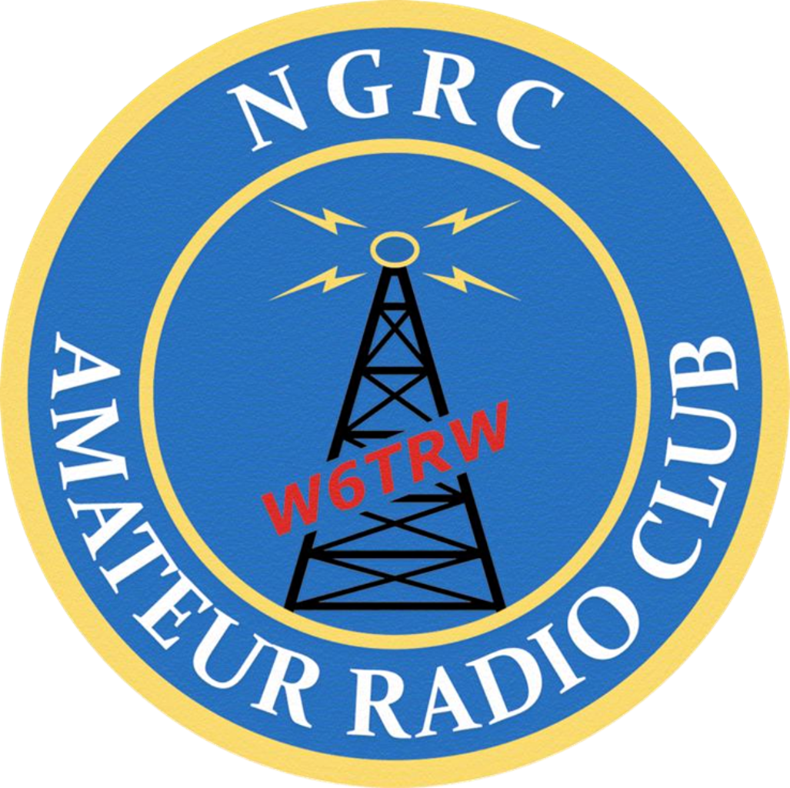 | NGRC  Amateur Radio Association  Membership Application  Each member needs a separate application
PLEASE COMPLETE ALL 3 PAGES, PRINT LEGIBLY & SIGN
Illegible writing will cause errors in database that may cause mail (or e-mail) to be lost.
This application is for: |  | 2023 The membership year is from January 1st to December 31st
Name: |  |  | Date:

Amateur Call Sign: |  | License: | Tech |  | Gen |  | Adv |  | Extra

Under age 18? |  | ARRL Member? |  | US Citizen / Person?
Current Northrop Grumman Employees Only:
MyID Number: |  |  |  |  |  |  |  |  | CCC:
Mail Station: |  |  |  |  |  | Telephone No:
Job Function:
 |  |  | i.e. Business, Mechanical Engineer, Software Engineer…
All Members:
Home Address:
City: |  |  |  |  |  |  | State: |  |  |  | Zip Code:
Home Phone: |  |  |  |  |  |  | Cell Phone:
E-mail address(es):
The information collected herein is used only for communication with members, to meet legal requirements regarding liability, and for emergency contact in case of a member’s illness or injury while participating in a club activity.

Participation Fees
Participation Fee | $5.00
Engraved Name Tag | $30.00 |  | (Badge free for members who renew prior to 1 March 2020)
Lifetime Member | NC
Total Due:

For digital payment with Venmo, Zelle, or PayPal, please email your completed form to Club President Dylon Mutz, at dylon.mutz@ngc.com, and indicate your preferred payment platform.
For check payment, please make check(s) payable to the SPSC AMATEUR RADIO ASSOCIATION and mail to:
NGRC W6TRW AMATEUR RADIO ASSOCIATION
Membership Chairperson
One Space Park, M/S NGRC K09774/S
Redondo Beach, CA 90278

Please Check Your Club Interests:
Baker to Vegas: Field Day: Swap Meet Support: Club Officer: Satellite Operations:
Radio Direction Finding: Other: _____________________________
RELEASE OF LIABILITY AND INDEMNITY AGREEMENT - NGRC
I, , hereby acknowledge that I have voluntarily applied to participate in
the Amateur Radio Association through the Northrop Grumman Recreation Club (hereafter referred to as “NGRC”).
I am aware that Amateur Radio is a hazardous activity and I am voluntarily participating in this activity with knowledge of the danger involved. I hereby agree to accept and assume any and all risks associated with or related to such activity or any instruction in such activity, including, without limitation, the risk of injury or death. Please initial _ _.

In consideration for being permitted by NGRC or one of its affiliated organizations including, without limitations, Northrop Grumman Corporation (hereafter referred to as “NGC”) to participate in these activities, I hereby agree that:

- I, my heirs, executors, legal representatives, administrators, guardians, and assignees will not make a claim against, sue, attach the property of, or prosecute NGRC, NGC, its or their affiliated entities, employees, agents, officers, directors, shareholders (hereafter collectively referred to as “Released Parties”) for injury, or damage resulting from the negligence, lack of due care, strict liability, personal injury, property damage, warranty, or other acts exclusive of fraud or intentional wrongful acts, (hereafter collectively referred to as the “Released Claims”), howsoever caused, by any employee, agent, or contractor of Released Parties, as a result of or related to my participation in or instruction in said activity;

- I voluntarily forever release, discharge, waive and relinquish any and all Released Claims wherever or however the same occur and for whatever period said activity or instruction may continue; and

- I assume all the risks associated with or related to such activity or the instruction in such activity and I do for myself, my heirs, executors, administrators and assigns hereby release, waive, discharge and relinquish any action or causes of action for the Released Claims which may hereafter arise for myself and my estate, and agree that under no circumstances will I or my heirs, executors, administrators and assigns prosecute or present any claim for the Released Claims against the Released Parties.

4. I, for myself, my heirs, executors, administrators and assigns, expressly waive the benefits of Section 1542 of the California Civil Code which provides as follows:

A GENERAL RELEASE DOES NOT EXTEND TO CLAIMS WHICH THE CREDITOR DOES NOT KNOW OR EXPECT TO EXIST IN HIS FAVOR AT THE TIME OF EXECUTING THE RELEASE, WHICH, IF KNOWN TO HIM, MUST HAVE MATERIALLY AFFECTED THE SETTLEMENT WITH DEBTOR.

I, for myself, my heirs, executors, administrators and assigns agree that, in the event any claim for the Released Claims shall be prosecuted or presented against any of the Released Parties I shall indemnify, defend, exonerate, pay, and save harmless such Released Party from any and all such claims or causes of action by whomever or wherever made or presented.

Notwithstanding the foregoing, this Agreement and Release of Liability does not extend to any claims for benefits I may have pursuant to the terms of any of Northrop Grumman Corporation’s group medical or dental insurance plans for employees and eligible dependents. Parent or Guardian signature required if participant is under 18 years old.

I have carefully read this agreement and fully understand its contents. I am aware that this is a release of liability and a contract between myself and Northrop Grumman Recreation Club and/or its affiliated organizations and sign it of my own free will. Please initial _ _.

Signature: Date

Parent/Guardian (If uNder 18): Date

NGRC - Member’s Code of Conduct
As a Member of NGRC, I understand that I must follow these rules to remain in good standing:
- I hereby pledge to be positive about my activities/sports experience and accept responsibility for my participation by following this Member’s Code of Conduct.
- I will encourage good sportsmanship from other members, players, team captains, and officials at every activity/game by demonstrating good sportsmanship.
- I will treat my fellow members, team captain, other players, officials and fans with respect regardless of ability, race, sex, creed, age, national origin, ethnicity, religion or sexual orientation or other personal characteristic and will expect to be treated accordingly.
- I will refrain from the use of foul or inappropriate language.
- I deserve to participate/play in an environment that is free of un-lawful or un-prescribed drugs, tobacco and alcohol and expect others to refrain from their use at all activities/sports events.
- I will follow the NGRC bylaws.
- I will remember that activities/sports are an opportunity to learn and have fun.
- I agree to adhere to the NGRC ARC Standard Operating Procedures (SOPs).

I hereby acknowledge that I have read and understand the above and agree to be held bound by the Member’s Code of Conduct. If I fail to act as described in the Member’s Code of Conduct, I fully understand that I will no longer be able to participate in activities associated with any NGRCs.

Signature: Date

Parent/GuardiaN (If uNder 18): Date

Sign In & Model Release

By signing this release, I grant Northrop Grumman Systems Corporation (the “Company”) and its assigns and
licensees, the absolute and irrevocable right and permission to use and reuse all photographs, video and audio of me (“Photographs”) or in which I may be included, in whatever format or medium they may appear, together with my name, for purposes of the Company’s advertisement, trade or promotion. I agree that the Photographs may be combined with other images, text, graphics, film, audio, audio‐visual works; and may be cropped, altered or modified.

I hereby assign all rights in the Photographs, including all copyright rights I may have, to the Company and agree that all Photographs taken of me by or for the Company shall be owned by the Company, and that if I should receive any print, negative or other copy thereof, I shall not authorize its use by anyone else.

I waive any right that I may have to inspect or approve the finished product or advertising copy in which a Photograph may be used. I acknowledge and agree that I have no further right to additional consideration or accounting, and that I will make no further claim for any reason to the Company.

I warrant that I am eighteen (18) years old or older and have read this release and fully understand and agree to the contents hereof. I hereby release the Company together with its employees, agents, assigns, licensees and successors from any claim that may arise regarding the use of photographs containing my image, including any claims of defamation, invasion of privacy, infringement of moral rights, right of publicity or copyright. The Company is permitted, although not obligated, to include my name in connection with its use of the Photographs. I agree that this release shall apply to all Photographs taken of me during my employment with the Company, its subsidiaries, affiliates, related companies, and its and their successors.

EMPLOYEES: Must also fill out the on-line form on the NG home page and check here that you have done so:
Signature: Date

Parent/GuardiaN (If uNder 18): Date

Not signing means we will not use your picture in any club related materials. You are responsible for not posing in any group photos at club activities.

